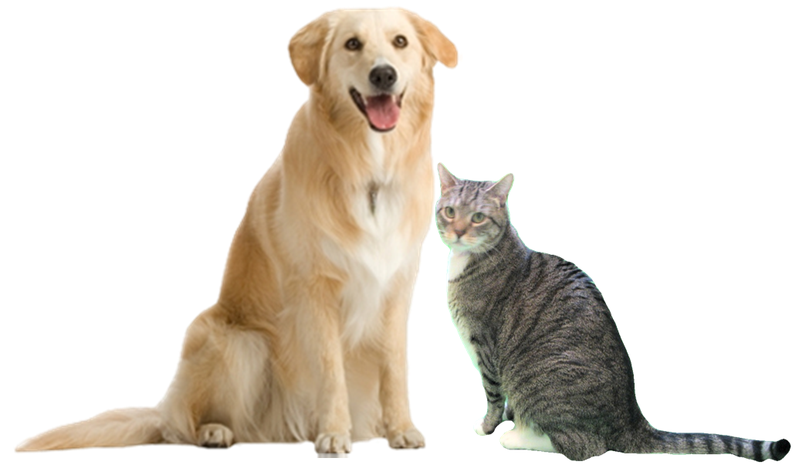
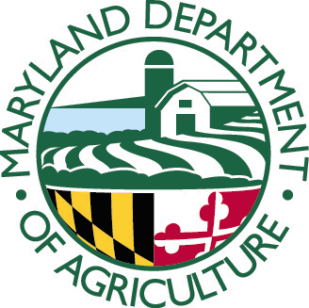
2018 Pet-Focused Application Form

The following application form is used for projects that focus on pet dogs and cats and training.
(Projects with the focus on feral cats or for capital expense/equipment request need to use the Feral Cat-Focused Application form or the Capital Expense/Equipment Application form)

Applicants seeking funds to spay/neuter pet cats and dogs should be aware of the following criteria and requirements:
- Municipal or county governments or non-profit animal welfare organizations with tax exempt status under 501 (c)(3) are eligible to apply to facilitate and promote the provision of spay and neuter services for cats and dogs.

- A competitive grant proposal:
Shall target low–income communities and populations to the maximum extent possible and detail how that goal is to be accomplished;
Shall efficiently and effectively facilitate and promote and increase the provision of spay and neuter services for cats and dogs; and
May include public education and outreach components.

- Grant projects must meet the purpose of the Fund. Grant projects that most effectively and efficiently facilitate, promote and increase spay and neuter services for cats and dogs for low income Marylanders will be given priority.

- Applicants must comply with all other statutory and regulatory requirements pertaining to the Spay/Neuter grant program. Applicants should familiarize themselves with those provisions of the Maryland Code. Program Regulations

- The Applicant and personnel who will work on the project must have the qualifications and resources (reflected in the application) necessary to perform and complete the work proposed in the application.

- Applicants that conduct spay/neutering using other funds should provide a “net increase” in surgeries. These funds cannot be used to maintain the organization’s status quo or replace other funds.

- Applicants and their organizations should have no history of violations or fines with Maryland Animal Control authorities and any history of violations may be a basis for denying funding.

- Applicants shall coordinate with local animal control and shelter staff to confirm their project would impact intake and euthanasia.

- Applicants must be in good standing with the State of Maryland.

- Applicants with shelters must be in compliance with the Standards of Care requirements set forth by Sections 2-1701 through 2-1705 under Subtitle 17, Animal Shelters, in the Agricultural Article of the Annotated Code of Maryland.

- Applicants must complete and submit the grant application, with any required attachments as specified in these Guidelines and on the application forms by close of business (5:00 PM EST) on or before the posted grant deadline as it appears on the Request for Proposals (RFP) and on the MDA website (Spay and Neuter Grants Program webpage).

Please read all the Guidelines Before Completing this Application
MARYLAND DEPARTMENT OF AGRICULTURE
SPAY AND NEUTER GRANTS PROGRAM
2018 PET-FOCUSED APPLICATION FORM
The purpose of the program is to reduce animal shelter overpopulation and cat and dog euthanasia rates by financing grants to local government facilities and animal welfare organizations for programs that most efficiently and effectively facilitate and promote the provision of spay and neuter services for cats and dogs in the State.
All fields are MANDATORY. Application fields left blank may cause your application to be deemed incomplete and ineligible for further consideration. Any fields that are not applicable to your application should be indicated by entering “N/A”. The text fields in this form will expand as you enter your narrative. You may also attach extra page(s) if necessary.
Please carefully proof read all of your text and check your math before submitting your application.
A. PROPOSAL ADMINISTRATION INFORMATION
Title of Proposed Project |  |  |  |  |  |  |  |  |  | Proposal Ref #  (for MDA use only)
Total Amount Requested  No less than $5,000 |  |  |  |  |  |  |  |  |  | Prop Ref #
Name of Requesting Organization |  |  |  |  |  |  | Address, City, State,  Zip Code
Phone | Fax of Applying Organization |  |  | Phone:  Fax: |  |  |  | Website Address, if any

MDA Spay and Neuter Grants Program Criteria and Requirements

By checking the following appropriate boxes, the applicant certifies that the applicant meets our program basic criteria by:

(Please CHECK):

Being a Municipal or County Government, OR
Being a Private Organization contracted by a county to provide animal services, OR
Being an Animal Welfare Organization with tax exempt status under 501 (c) (3). If so, please attach a PDF of your most current IRS Form 990 if applicable.
AND:
Being an Applicant that is in good standing with the State of Maryland.
If the Applicant shelters animals, the Applicant is in compliance with Standards of Care requirements of Sections 2-1701 through 2-1705, Subtitle 17, Animal Shelters, in the Agricultural Article of the Annotated Code of Maryland.
Applicant guarantees that their project personnel or organization has no history of fines or violations with any Maryland Animal Control Authorities or if so has clarified the matter with MDA prior to submittal.
B. POINT OF CONTACT & ORGANIZATION INFORMATION
Name of Organization’s Primary Point of Contact (POC): |  |  |  |  | Name of Organization’s Financial Point of Contact (FPOC):
Title: |  |  |  |  | Title:
Phone (and ext. if applicable): |  |  |  |  | Phone (and ext if applicable):
Email: |  |  |  |  | Email:
Employer Identification Number:
Applying Organization: Number of Staff: Number of Volunteers:
Briefly describe your organization (i.e. when established, # of animals you typically intake in a quarter, the area(s) you service, etc.) Only include information pertinent to the work you are proposing in this application (see Guidelines):

Operating Budget for 2017: Operating Budget for 2016:
Number of low cost spay/neuter procedures your facility/organization has provided or facilitated each year for the last 3 years:
# of procedures for 2015: # of procedures for 2016: # of procedures for 2017:
If the number of surgeries your organization has facilitated has decreased from previous years, please explain why:
Please summarize any grants your organization has received in the last 3 years, including grants from MDA (you should be brief: From whom, how much, what was accomplished and where):
Are you applying for another grant from this Program for this cycle? Please CHECK appropriate box.
No, this is our only application for this cycle. Proceed to Section C. Yes, we are submitting a second application to this program for this cycle.
IF YES- Please confirm that your organization has the capacity to perform all the tasks for all the applications proposed:

If your 2 applications are related to the same project, please state whether your organization has the capacity and resources to move forward with the project if MDA recommends funding one of your applications but not the other:

If your 2 applications are independent from each other, please indicate which application you feel should have priority if the Program can only fund one of your applications:

PLEASE BE SURE TO SUBMIT YOUR ORGANIZATION’S MOST RECENT IRS 990 IF REQUIRED BY IRS.
 | C. PROJECT DETAILS

C-1- Period of Performance: Please give the start date and end date to your project (month and year). Project should be no more than 12 months:

Start: End:
 | C-2- Project Description: Describe what you propose to do with the grant. This should be a brief summary. The details should be provided in subsequent sections of the application form:

C-3-a- Expected Outcomes: How many dogs and cats do you expect to spay or neuter by your project. The cost/surgery should match that stated in Price Assurance Form(s) and Budget Section:
# of cats spayed: | Costs per cat spay: | # of cats neutered: | Costs per cat neuter:
# of dogs spayed: | Costs of dog spay: | # of dogs neutered: | Costs per dog neuter:

 | C-3-b- Shelter Statistics: Please provide the intake and euthanasia numbers for the last 3 years for any shelter in your target area:
Shelter Name and County:
 | Total Intake for: 2015/2016/2017 | Total Euthanasia for: 2015/2016/2017
Cats | / / | / /
Dogs | / / | / /
Shelter Name and County (if your target area occurs in more than 1 county):
 | Total Intake for: 2015/2016/2017 | Total Euthanasia for: 2015/2016/2017
Cats | / / | / /
Dogs | / / | / /

If you were able to obtain any additional data drilled down to your specific target area (by zip code, neighborhood, etc) please provide information here. Also use this space, if necessary, to provide any additional data you may have from other sources:

 | C-3-c- Project Impact: Detail how each shelter you listed above will benefit from your project and to what extent (numbers reduced, percent reductions, etc.) you anticipate your project will impact shelter intake and euthanasia:
 | C-4- Partnering: If your project involves partnering with another organization please list the organization name, a brief description of their expertise, and what part they will serve in the project (any financial contributions from partners should be listed in Section F. below):
C-5- Target Area: Identify the location (target area or population) of your project. Explain how you determined that this area or population meets the criteria of “low income” and has a significant population of unaltered dogs and/or cats. Also include a discussion on how your target area is a source of intake to local shelters. Please reference specific numbers from shelter data. Discuss estimated number of unaltered pets for the area using Pet Estimate Tool (see Guidelines-Application Sections and Program webpage for the Pet Estimate Tool):

Please CHECK: I have included the required map with my application, indicating where the project target area is located.
Please CHECK: I have included a copy of the Pet Estimate Tool page we used to calculate number of unaltered pets in our target area(s).
 | C-6-A Detailed Work Plan: Concisely describe in a step by step timeline the activities and/or tasks that will be performed to accomplish the objectives of the project, including means testing (i.e. the specific criteria you will use to determine if a pet owner qualifies for the service):
 | C-7- Outreach Plan: Detail how you will reach the targeted community about your project to maximize public participation. Items to cover: type of marketing, outreach, method of distribution, time line, etc. Provide price quotes for items $500 or more. If signage is proposed, provide a draft of the text to be used:
C-8-Project Support: Discuss any additional endorsements you have obtained or sought from animal control, local shelters, government agencies, and other animal welfare organizations that may benefit from your project, providing documentation of communications if necessary:

Please CHECK: I have included copies of all Letters of Support and Endorsement, or documentation of coordination attempts, with my application.
 | C-9-Key Personnel: List the key personnel (excluding veterinary staff which should be detailed in Section C-10), qualifications, and the kind of task(s) he/she will perform:

C-10-Veterinarian Practice/Clinic Capacity: List the veterinarian(s) or clinic(s) you propose to use for your project and confirm that you have discussed this proposal with the veterinarian or clinic with regards to their capacity to perform the number of procedures you propose should you be funded:
Please CHECK: Our veterinarian/clinic has the capacity to perform these procedures in within the period of performance.

Please list the full name of the veterinarian(s) and clinic(s) you plan to use. Please include current Maryland license number(s):

D. PROJECT BUDGET LINE ITEMS AND JUSTIFICATIONS
Type |  | D-1-Description of budget items: Please see Guidelines for more information on allowable expenses and how to describe them in this Section. Please Note- Incomplete or vague budget items will not be considered and may be a basis for downgrading the application. |  |  | Total Amount Requested
Veterinary Services |  | Cost of cat spays: / cat- and- # of spayed cats proposed:
Veterinary Services |  | Cost of cat neuters: / cat-and -# of neutered cats proposed:
Veterinary Services |  | Cost of dog spays: / dog-and- # of spayed dogs proposed:
Veterinary Services |  | Cost of dog neuters: / dog-and- # of neutered dogs proposed:
Rabies Vaccine (capped at $5/dose) |  | Number of doses: Cost/Dose:  CHECK here ONLY IF the cost for rabies vaccinations is coming from another source and so is not being requested in this application and may be considered a cost sharing item.  (See Section E.)

TOTAL BUDGET REQUEST (Form DOES NOT automatically total. Double Check Your Math! And make sure this matches the total amount requested in Section A)
Attach pages if more space is required. Include vendor quotes for equipment.

D-2- Budget Items Justifications: List your budget items (excluding surgical costs and rabies vaccinations-these do not require justification) and why each is necessary and at the cost proposed:

E. ANY COST SHARING OR IN-KIND CONTRIBUTIONS

Obtaining cost sharing and/or matching funds is strongly encouraged to maximize program funds and project effectiveness. If you do have cost sharing and/or matching funds that will be directly associated with this project please describe and quantify to the extent possible. Cost sharing can be in the form of real dollars or in-kind contributions (such as organization loaning equipment, space, volunteers, or other services. Example: ABC Animal Hospital-1 vet technician volunteering services for 8 hrs @$15.00/hr- $120.00). It is important to assign an estimated dollar value to each contribution.
Organization |  |  | Description of Cost Share or Funds | Est. $ Value

Provide a separate page if you need more space. Total (Please check your math):

F. ANY MATCHING GRANTS/FUNDING
Matching Grants/Funding: If this project is dependent on another grant or additional funding from either this program or another source, please discuss here. Please give details and provide copies of documentation (including the amount of additional requested funding, funding source, any requirements or parameters related to that additional funding source, and whether the funds have already been secured):

Final Acknowledgements Please CHECK:
All fields in this application have been filled in. Any field not applicable to this application should be indicated by the entry “N/A”. The Applicant understands that blank fields may be construed missing information and the application may be considered incomplete and removed from further consideration.
To the best of the Applicant’s knowledge all information provided in this application is true and accurate.
The Applicant understands that requiring payments (“co-pays”) for any service covered under this grant is not allowed.
The Applicant has included: the Price Assurance Statement from the veterinarian(s) and or clinic(s), copy of most recent 990 (if applicable), any maps, Pet Estimate Tool page, Standards of Care Plan (if applicable), price quote for equipment (if applicable) and letters of support from Animal Control/Shelter personnel or other government agency.
Date Submitted: Name of Submitter:
Please send your completed application (and any attachments) before the close of business (5:00 PM EST) of the proposal due date stated in the RFP. Please submit as an email attachment to: mda.spayandneuter@maryland.gov. Applications submitted to any other email address, faxed or mailed will not be accepted. NOTE: Once submitted, changes are not permitted. If you have any questions, please Contact: Jane Mallory, Program Coordinator, Spay and Neuter Grants Program, Maryland Department of Agriculture at Jane.Mallory@maryland.gov or call 410-841-5766.

