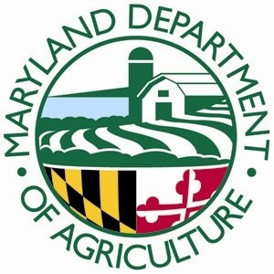

Poultry and Rabbit Processing

Certification Training

[Type a quote from the document or the summary of an interesting point. You can position the text box anywhere in the document. Use the Text Box Tools tab to change the formatting of the pull quote text box.]

**Maryland Department of Agriculture**

**50 Harry S. Truman Parkway**

**Annapolis, MD 21401**

**Lower Level Conference Rooms**

**March 31, 2014**

**Calvert County Economic Development Building**

**205 Main Street**

**Prince Frederick, MD 20678**

**April 11, 2014**

**Sign in: 8:30am**

**Course: 9:00 am to 4:00 pm**

The Maryland Department of Agriculture (MDA) will conduct training for on-farm poultry and rabbit slaughter and processing. This one-day workshop is mandatory for producers who want to become certified to slaughter their poultry and\or rabbits for sales at farmers’ markets and to retailers and restaurants in Maryland. Producers selling their poultry and\or rabbits directly to consumers on the farm are not required to take this training or be certified by MDA. Workshop participants will learn how to recognize diseases of public health concern, basic biosecurity measures, how to write and implement basic Standard Sanitary Operating Procedures, Good Manufacturing Practices and Hazard Analysis and Critical Control Point plans, offal and waste water disposal.

To become certified, producers must:

* Complete the training
* Pass a brief test at the training
* Submit an application for certification along with a $75.00 annual fee
* Be inspected by MDA

Training registration fee is $25 per person which includes lunch and training materials. Make checks payable and mail with registration form to:

MDA, FQAP

50 Harry S Truman Parkway

Annapolis, MD 21401

Space is limited, so register early REGISTRATION DEADLINE: March 20, 2014 for Annapolis; April 1, 2014 for Prince Frederick

For more information contact:

Sherry Weygant at 410-841-5769 or sherry.weygant@maryland.gov

REGISTRATION FORM

Farm/Producer Name:

Address:

City: State: Zip:

Phone: Email:

Choice of class attending must be marked

□ March 31, 2014 Annapolis, MD □ April 11, 2014 Prince Frederick, MD

Participant Name(s) and Titles:

PCA 23203 OBJ 7647