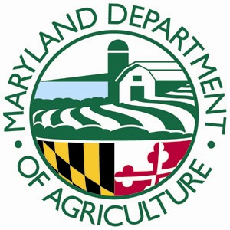
Office of Plant Protection & Weed Management
50 Harry S Truman Parkway
Annapolis, Maryland 21401
www.mda.maryland.gov

REGISTRATION FORM
Boxwood Blight Training, February 16, 2017
Maryland Department of Agriculture, Annapolis, MD

Name: _________________________________________________________________
Title: __________________________________________________________________
Company Name: ________________________________________________________
Address: _______________________________________________________________
Phone: _________________________________________________________________
Email: _________________________________________________________________

Meeting Agenda

8:00 - 8:30 Introduction and Importance of Boxwood Blight
8:30 - 9:00 How to Identify the Disease
9:00 - 9:15 Break
9:15 - 10:00 Disease Management Strategies
10:00 - 10:30 Pennsylvania Quarantine and Compliance Agreement
10:30 - 10:45 Break
10:45 - 12:00 Where do I stand on the compliance agreement: Q&A

The training seminar is limited to 50 participants.
Registration form must be received by Feb. 1, 2017.
Please email to: ppwm.mda@maryland.gov , fax to 410.841.5835, or mail to Maryland Department of Agriculture, Plant Protection and Weed Management, 50 Harry S Truman Parkway, Annapolis, MD 21401.

**If you have any questions, call us at 410-841-5920**

