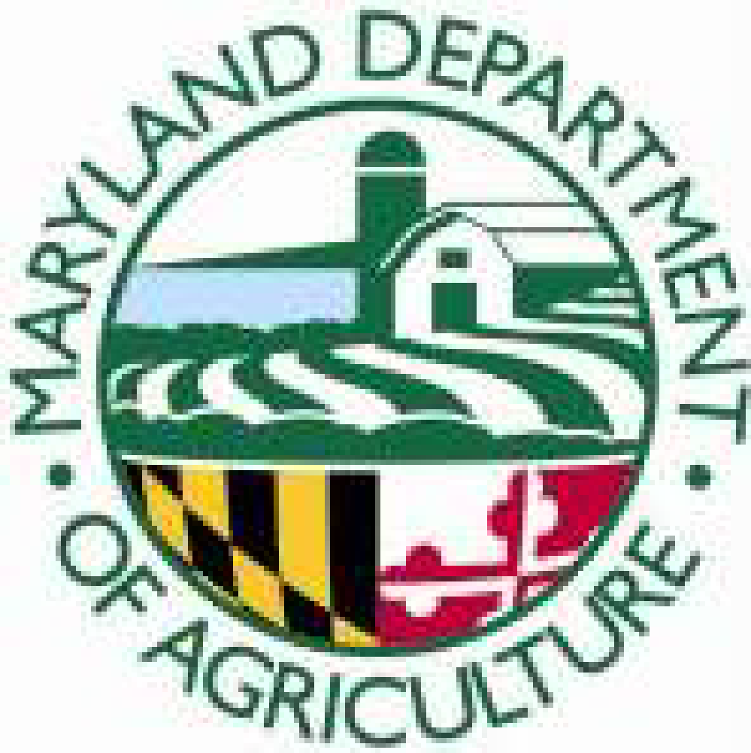
Maryland Department of Agriculture
Animal Health Section
50 Harry S. Truman Parkway
Annapolis, Maryland 21401
MDAPoultry.Testers@maryland.gov

APPLICATION FOR NEW MARYLAND AUTHORIZED POULTRY TESTING AGENT CLASS

Applicants must attend class and pass a written open book exam to qualify for the wet lab session of class to be scheduled individually with each student. Class is approximately 2 hours.

Instructions:
- Please Print Clearly.
- Applicants must be at least 18 years of age.

Name: _____ _______
First M.I. Last

Address:
Street or Box Number

City State Zip County

Telephone: Cell:________________________________

Email Address:

November 12th 10am Salisbury Animal Health Laboratory 27722 Nanticoke Rd, Salisbury, MD 21801

November 19th^{th} 10am Frederick Animal Health Laboratory 1840 Rosemont Avenue Frederick, MD 21702

SEND APPLICATION ALONG WITH A CHECK FOR $25 MADE OUT TO MDA TO:

MD Department of Agriculture
Animal Health
50 Harry S. Truman Parkway
Annapolis, MD 21401

The deadline for applications/payment is November 4th 2022.

