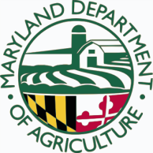 |  | Project #  -

County:
Defending Our Nation's Resources

Defending Our Nation's Resources

Defending Our Nation's Resources

Defending Our Nation's Resources

Defending Our Nation's Resources

Defending Our Nation's Resources

Number of Cats Spayed: Number of Dogs Spayed:
Number of Cats Neutered: Number of Dogs Neutered:

Amount Received: Amount Remaining (to be returned to MDA):

Project Synopsis:

Project Description:

Summary of Approach:

Accomplishments:

Lessons Learned:

Attachments:

For More Information Contact:
Name:
,

Organization Name and Address:

Email:

