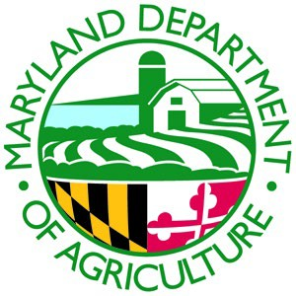
On Farm Readiness Review (OFRR) Request
On Farm Readiness Reviews are being offered by MDA, UMD, and UME teams. The purpose is to help you better understand and meet the requirements of the federal Food Safety Modernization Act (FSMA) Produce Safety Rule (PSR). The OFRRs are free and conﬁdential. The OFRRs are not regulatory – the purpose is to provide education and technical assistance to farmers who are required to comply with the PSR. You will be sent an OFRR manual prior to the OFRR that includes valuable information on ways to comply with each section of the PSR. The Maryland Team will walk around your farm with you to observe and discuss your practices and compliance with the PSR. At the end of the review, you will receive notes speciﬁc to your operation on areas that are compliant and those that may need improvement. The team will be available for follow-up assistance if needed.
Name of Farm:
Contact for Farm:
Contact Phone Number:
Contact Email:
Farm Address:
The following information is requested to prioritize scheduling:
Have you or anyone on your farm taken the Produce Safety Alliance Produce Safety Rule Grower Training?
Yes No
What size is your farm (acres or sq ft):
What covered activities take place on your farm? (check all that apply)
Growing Harvesting Packing Holding Covered Produce Grown:

Growing Period (mm/dd-mm/dd): Year Round
Planting Period (mm/dd-mm/dd): Year Round
Harvesting/Packing Period (mm/dd-mm/dd): Year Round Financial category:
Large (>$500,000); Small ($250,000-500,000); Very Small ($25,000-250,000); Exempt (<$25,000)
Completed forms can be emailed to produce.safety@maryland.gov, faxed to 410-841-2750, or mailed to: Food Quality Assurance Program, Maryland Department of Agriculture 50 Harry S. Truman Parkway, Annapolis, MD 21401
Once we receive your form, we will contact you to ﬁnd out more about your farm to personalize your OFRR and set a date and time. Please contact us at 410-841-5769 or produce.safety@maryland.gov if you have any questions.
Revised 04/22/2024
This publication is supported by the Food and Drug Administration (FDA) of the U.S. Department of Health and Human Services (HHS) as part of a ﬁnancial assistance award U2FFD007444 totaling $1,280,384 with 100 percent funded by FDA/HHS. The contents are those of the author(s) and do not necessarily represent the official views of, nor an endorsement, by FDA/HHS, or the U.S. Government.

