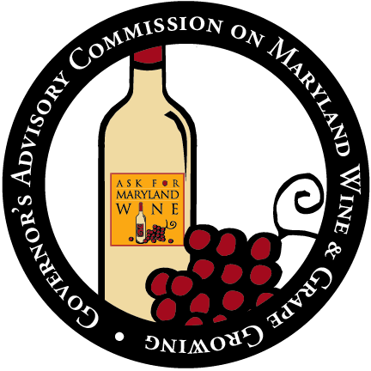
2020 Maryland Wine and Grape Promotion Fund
Proposal Application

Please submit your proposal as an email attachment in Microsoft Word to Karen Fedor, Karen.fedor@maryland.gov. Use 12-point Times New Roman or Arial font size. Application proposal are limited to 12 pages. If the application is sent by email, the submission inbox has a 20 megabyte limit. Deadline: May 15, 2020.

Organization Information
Organization Name: |  |  |  |  |  | Official Use Only:
Primary Point of Contact Name:
Street Address:

City: |  |  | State: |  | Zip:
Phone: |  | Email:
Federal Tax ID Number or EIN:

Financial Point of Contact Name (if different than Primary): |  | Financial Contact Info:
Is the organization in “Good Standing” with the State. Check the State Dept. of Assessments and Taxation (SDAT) website and include a screenshot. Yes No
Project Information
Project Title: |  | Grant period (start and end date of your project):
Total Project Cost:  $ | Grant Request:  $ |  |  | Match:  $
Workforce Development
Are you applying to the EARN Maryland Workforce Development Grant? Yes No

Project Summary: Provide a description of the project in two or three sentences.

Background: What is the nature and magnitude of the problem your project is trying to address? For example, does it relate to the quantity or the quality of wine grapes in Maryland? Does it relate to the financial feasibility and sustainability of wine grape growing or winemaking in Maryland? Please be as precise as possible in your measurement of the problem.

Project Aim(s) and Justification: Describe project aim(s). Describe how and to what extent your proposed project will address the problem(s) described above.

Project Description: Describe the project activities.

If research, describe 1) research questions), 2) current evidence on the research question and knowledge gaps; 3) why this topic is critical to the Maryland grape and wine industry at this time; 4) research design; 5) data sources; 6) analysis plan; 7) plan for dissemination of findings.

If workforce development, please include 1) needs assessment justifying training; 2) plan for curriculum development; 3) plan for recruitment of participants; 4) estimates of target beneficiaries (type and numbers) and 5) an evaluation plan to assess impact.

Staffing: Please provide a staffing plan, including qualifications of the lead personnel. If academic please provide a resume or Curriculum Vitae of key researchers or faculty.

Anticipated Deliverables: List the anticipated outputs of the project, as well as the short term and long term impacts.

Timeline: Provide an approximate schedule for project implementation.

Partner Organizations: List the partner agencies and groups that are participating in the proposed project and how they are contributing to the overall effort. Please include Letters of Recommendations. The Commission recommends inclusion of at least three letters of support from Maryland vineyard and/or winery owners that explain in detail how the project could potentially benefit their business and the industry as a whole.

If any co-funding is available or has been solicited, please provide details.

Budget (please use Attachments A & B for the budget). Please demonstrate partner’s commitment to the project by providing letters of support. The grant recipient must keep complete records that identify and document the specific costs or contributions proposed to meet the match, the source of funding or contributions, and document how the valuation was determined.

Sustaining the project: When the project has ended, please explain how will the efforts be sustained?

If you have questions, please contact Karen Fedor at 410-841-5773 or Karen.Fedor@maryland.gov.

Final Acknowledgments:

___ I understand that failure to provide all the information requested in this application may disqualify me from funding consideration. I have therefore checked all sections for completeness.

___I acknowledge that all information provide in this application is true and accurate.

Attachment A: Proposed Budget
Use this sheet to show all project funds, all grant funds, and all matching funds, as well as all sources of these funds. Note this sheet does not automatically calculate totals.

Use Attachment B to explain these amounts.

Name of Applicant Organization:

Estimated Expenses | Wine & Grape Promotion Funds Requested | Federal, Local, Gov’t | Business & Industry | Other (Include other grants) | Total
A. Salaries & Wages
B. Fringe Benefits
C. Travel
D. Equipment
E.
F.
G.
TOTAL DIRECT COSTS
H. Other Costs
Materials & Supplies
Pubs./Documentation
Consultant Services
Subcontracts
Other:
Other:
Other:
TOTAL OTHER COSTS
TOTAL Project Cost*

Use this sheet to provide a narrative that explains each amount on your Proposed Budget. (For instance, if your spreadsheet shows $5,000 in travel from business/industry, explain where those funds came from, how they will be used, and what restrictions there are in using them, if any.) Be concise but complete. Use as much space as you need.
Name of Applicant and Project:

Line A: Salaries & Wages –

Line B: Fringe Benefits –

Line C: Travel –

Line D: Equipment –

Line E:

Line F:

Line G:

Line H: Other Costs –

Attachment B: Line Item Budget

