Site Manager Checklist
- Create Clean/Dirty line (remember you can always make bigger but not smaller)
- Control the flow of traffic, people and vehicles
- Visitor logs, everyone on site checks in and out Daily
- No one crosses line without proper PPE (Tyvek, boot covers, gloves, hairnet, mask)
- Assist with supplies and requests at the line
- Upon leaving, observe doffing procedures and make sure properly disposed of
- Before exiting, everyone must be disinfected and hand sanitized
- Be observant of surroundings
- Work with Logistics on any needed supplies
- Any issues or concerns should be reported to Operations Section Chief ASAP
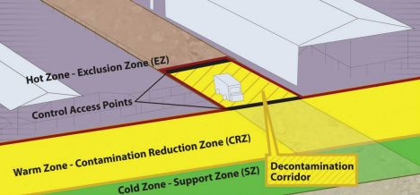

Supplies
Category 1 | Category 2 | Category 3
Tyvek | Virkon | Signage
Gloves | Sprayer | Flashlight
Boot Covers | Tubs/Pans | Important Phone numbers
Hairnets | Scrub Brush | Trash bags/Can
Masks | Visitor Logs | Dumpster
Safety Glasses | Caution Tape | Pens & Markers
Duct Tape | Cones | Bottled Water
Lysol | Tent?? | Table
Hand Sanitizer | Misc. Tools | Chair

