Register your Device

Business Information
Company Name |  | Point of Contact
Company Email |  | Company  Phone #
Address |  | Email
 |  | Federal Tax Id

Device Information
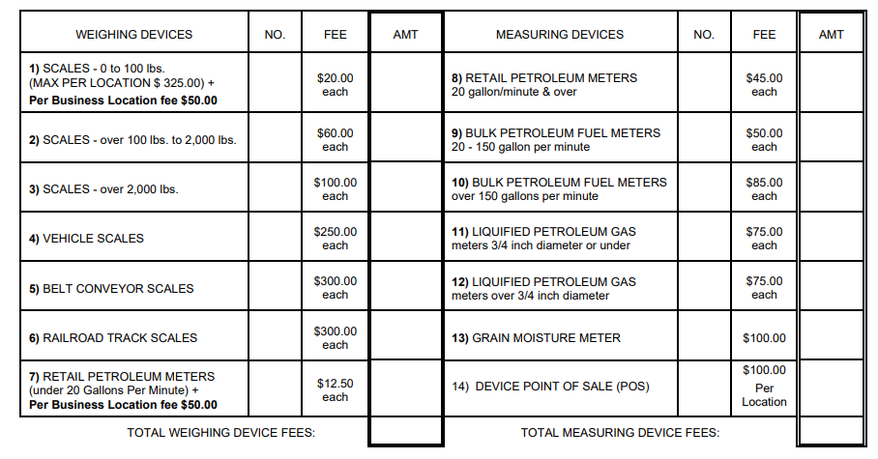

Please List the Certificate of Conformance of each device below.
________________________________________________________________________________________________________________________________________________________________________________________________________________________________________________________________________________________________________________________

Our Office will call you to confirm your devices before we register you. You will then receive an invoice to pay for your registration. A inspector will be sent out once the registration is complete.

